Designing A Particle Physics Experiment

Alessandro Schuetz

Oliver Oehlenberg

Ion Skalamera

Archimedes Wildhaber



Saturday, May 10, 2025

Table of Contents

2 Introduction 3

2.1 Motivation and Setup 3

2.2 Project Objectives 3

3 Determining the Average Decay Length of the Kaons 4

3.1 Methodology 4

3.2 Results 5

4 Simulation of Kaon Decay and Pion Kinematics 7

4.1 Simulation with an infinitely Narrow Beam 7

4.2 Simulation with Beam Divergence 8

5 Detector Optimization 10

5.1 Methodology 10

5.2 Results 10

6 Further Notes and Conclusion 11

6.1 Simulation Assumptions and Limitations 11

6.2 Reproducibility and Code Structure 11

6.3 Conclusion 11

7 List of Figures 12

8 Bibliography 12

# Introduction

## Motivation and Setup

The goal of the project is to optimize the layout of an experiment designed to measure the decay of charged kaons ( ) into a charged () and a neutral pion ().

The experimental setup consists of two detectors and utilizes a beam consisting of and . The first detector tags exclusively incoming kaons, while the second exclusively detects the outgoing and . The second detector has a circular cross-section with a 4-m diameter centered on the beam axis.

By performing a simulation of the experiment, idealized, we will determine the optimal distance between the two detectors that maximizes the number of events where both pions are successfully detected downstream.

In the idealized version of this experiment, we will not consider the further decay of the pions, and presume the beam is solely emitting Kaons, albeit with the same average decay length as calculated in section 3.

Figure 1: Illustration of the setup

## Project Objectives

This report is primarily structured around the secondary objectives outlined by Owen and Steinkamp (2025), concluding with the primary interest of determining the optimal detector distance:

1. Extract the mean decay length of kaons from a dataset containing decay lengths of both and decays from our beam
2. Generate decay vertices and simulate the resulting pion momenta using two body decay kinematics.
3. Apply Lorentz transformation to boost the decay products from rest frame to the lab frame.
4. Simulate both infinitely narrow divergent beam and one with angular divergence.
5. Determine the detector distance with maximal number of accepted events by calculating the intersection of the pions’ trajectories with a given detector position.

# Determining the Average Decay Length of the Kaons

## Methodology

To generate a sample of , we must know its average decay length for the exponential distribution. The momentum of the particles from the beam is unknown to us, instead being provided a dataset from a previous study using the same beam.

The data provided to us consists of a sample of measured decay lengths of a mixture of both and decays, drawn from our beam. The previous study did not distinguish between the two decays, however the composition is known to be consisting of 84% and 16% . Both particles decay exponentially with different decay lengths. For pions, the lab frame mean decay length is known to be .

We modelled the decay length distribution as a weighted sum of two exponential distributions:

(2.1)

where .

To estimate , we minimized the negative log likelihood with respect to the sample decay lengths :

(2.2)

The uncertainties are computed from a likelihood scan, where the upper and lower bounds are the value for which the NLL increases by 0.5 above the minimum, corresponding to the 68% confidence interval.

As a sanity check, we ensure that during the calculation of the logarithms none of the probabilities are so low as to trigger a division by zero in numpy.

## Results

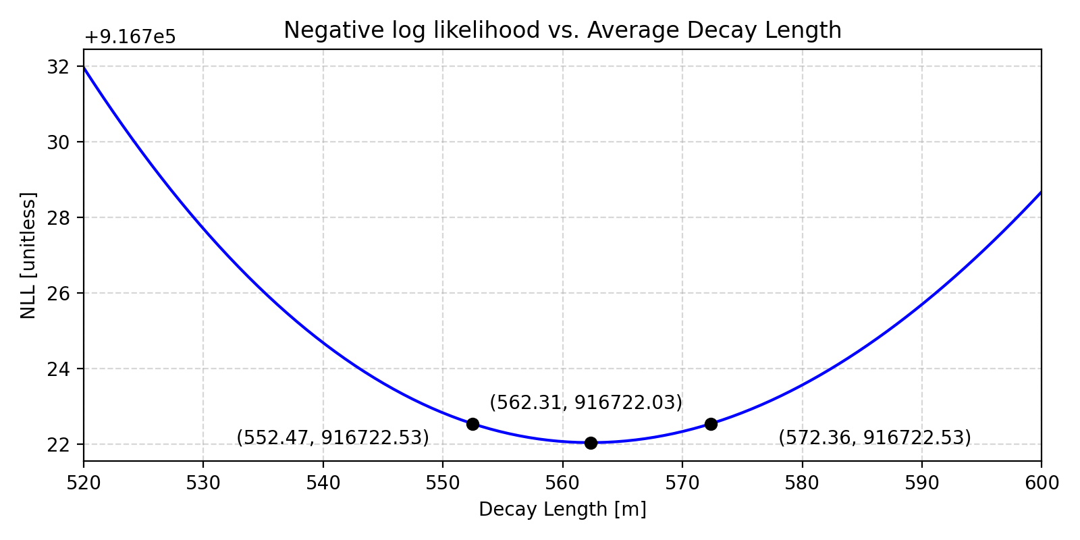

Figure 2: Fitted with uncertainty

The resulting average decay length is:

The following histogram of the provided decay lengths is overlaid with our distribution, substituted with the decay length calculated above.

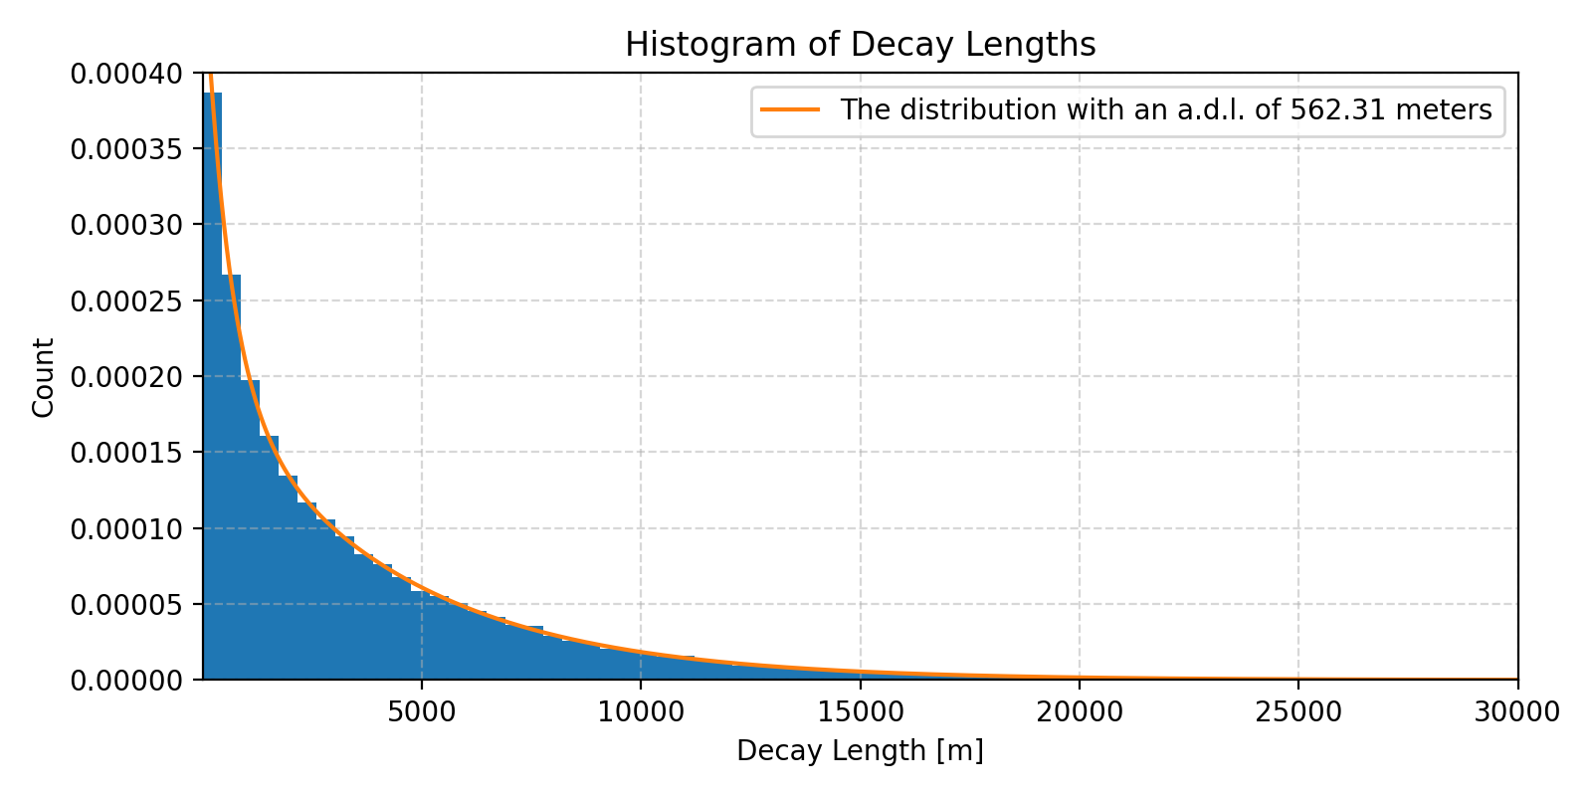

Figure 3: Fitted distribution overlaid onto a histogram of the decay lengths

We find that the fit agrees well with the plotted histogram, with the dominating long tail (very different decay lengths between charged and neutral pions) due to pions and the steep drop due to kaons.

Lastly, we shall compare our mean lifetime with the literature value. The momentum of the beam is unknown; however, the kaons and pions share the same magnitude of momentum:

(2.3)

Where , with being the speed of the respective particle and c the speed of light.

We also know that:

(2.4)

(2.5)

(2.6)

Plugging eq. 2.6 into eq. 2.3, and then eq. 2.3 into eq. 2.5 we obtain expression for mean Kaon lifetime:

Where mass of kaon , mass of pion , and mean pion lifetime .

Comparing this to literature value:

The values are compatible.

# Simulation of Kaon Decay and Pion Kinematics

## Simulation with an infinitely Narrow Beam

In this section we shall discuss the methodology and results for the special case of the kaons traveling along the z-axis with no angular divergence, and later in section 4.2 we shall consider the general case including angular divergence.

To simulate the position of kaon decays along the axis, the vertices are sampled from an exponential distribution based on the fitted mean decay length from the previous task:

(3.1)

The kaon decay is a two-body decay: .

In the rest frame of the kaon, by the conservation of momentum, we know that both pions have an equal and opposite momentum.

Note: The following calculations are in natural units

The magnitude of the momentum of both pions in the rest frame is given by (Wikipedia contributors, 2024):

(3.2)

The magnitude is then multiplied by isotopically generated directions to give the momenta of the pions.

The corresponding energy of the pion in kaon’s rest frame for the four-momenta is given by:

(3.3)

The four-momenta of the pion are then boosted using the special Lorentz transformation along z-axis:

(3.4)

Where and refers to the factors for using and are obtained by:

(3.5)

where , our fitted average decay length and the known lifetime of Kaons. We have thus obtained four-momenta of the pions in lab frame. All values obtained in this section are recorded for later use in detector optimization.

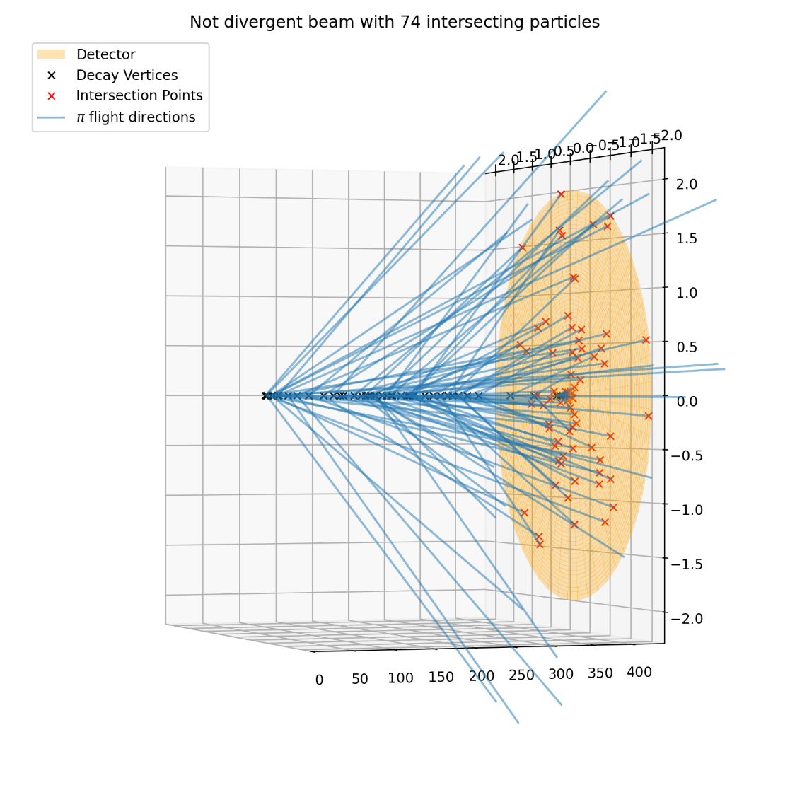

Figure 4: Subsample of 100 kaon decay vertices and their pions' flight directions with no angular divergence

## Simulation with Beam Divergence

In this section, the model is extended to simulate a more realistic kaon beam with finite angular divergence. Specifically, the polar angle of the kaon’s direction is drawn from a Gaussian distribution with a standard deviation of . The azimuthal angle is sampled uniformly from .

By the rotational symmetry of the problem, we can create our divergent sample by rotating the vectors from our non-divergent sample using rotation matrices we create from our angles.

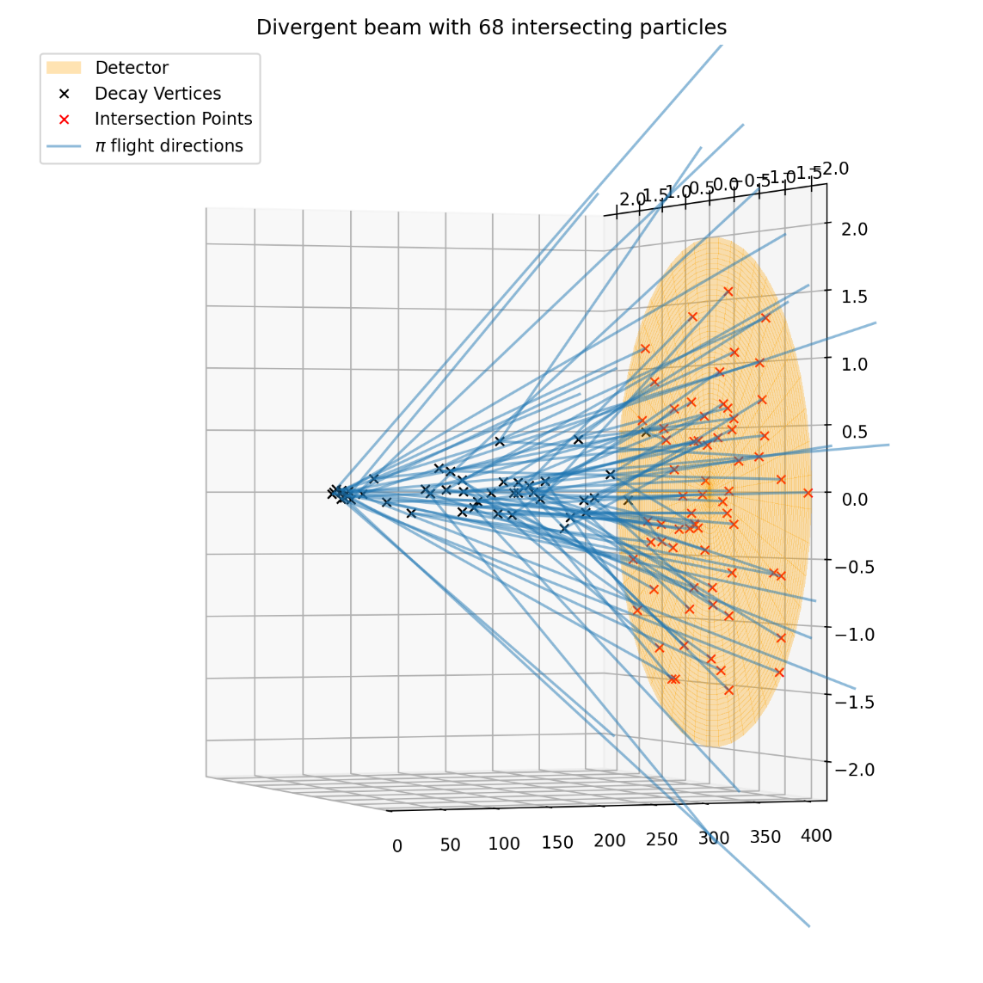

Figure 5: Subsample of 100 kaon decay vertices and their pions' flight directions with angular divergence

# Detector Optimization

## Methodology

The downstream detector is modelled as a 4 meter in diameter circular disk on the xy-plane centred on the z-axis. Decays behind the detector are assumed to not trigger events. To find the optimal distance between the detectors, we maximize the number of intersections, which is repeatedly calculated for different -values.

The method is applied to both the non-divergent and divergent beam modelled in sections 3 and 4.

## Results

|  |  |
| --- | --- |
|  | Optimal |
| Non-divergent Beam | 442.58 |
| Divergent Beam | 420.19 |

The result matches our expectation, as a finite divergence would cause a loss in number of events should the disk be too far away. That is the rapid loss due to divergence of the beam outweighs the gain from increased decay probability further downstream.

# Further Notes and Conclusion

## Simulation Assumptions and Limitations

Several simplifications were made in our simulation:

1. The pions won’t do not decay.
2. There are no interactions between particles.
3. All detectors were modelled to have full efficacy.
4. The kaon beam’s energy was assumed to be constant.

These assumptions simplified our analysis, however for a more accurate model/simulation they should be taken into consideration.

## Reproducibility, Code and raw data

All steps were implemented in Python. The random number generation was implemented using SPEC 7 compliant numpy Generator objects, with the seed saved in a file for reproducibility.

The code can be found at <https://github.com/Ion-1/phy241-project>.

The data we generated can be found in the repository under `./data/value_cache.json`, next to the seed stored as a pickled python integer in `entropy`.

## Conclusion

The analysis confirmed that the estimated kaon lifetime aligned closely with the literature value. Furthermore, it was found that introducing beam divergence slightly reduces the optimal distance for the detector. Thus, we conclude our analysis on optimized experiment layout for kaon decay.

# List of Figures

Figure 1: Illustration of the setup 3

Figure 2: Fitted with uncertainty 5

Figure 3: Fitted distribution overlaid onto a histogram of the decay lengths 5

Figure 4: Subsample of 100 kaon decay vertices and their pions' flight directions with no angular divergence 8

Figure 5: Subsample of 100 kaon decay vertices and their pions' flight directions with angular divergence 9

# Bibliography

Owen, P., & Steinkamp, O. (2025, April 8). *Designing a particle physics experiment*. UZH 25FS PHY241 Data Analysis II.

Wikipedia contributors. (2024). Particle decay#Two-body decay. In *Wikipedia*. Retrieved May 11, 2025, from https://en.wikipedia.org/wiki/Particle_decay#Two-body_decay